Rounding to the NEAREST TEN

Rounding to the NEAREST HUNDRED
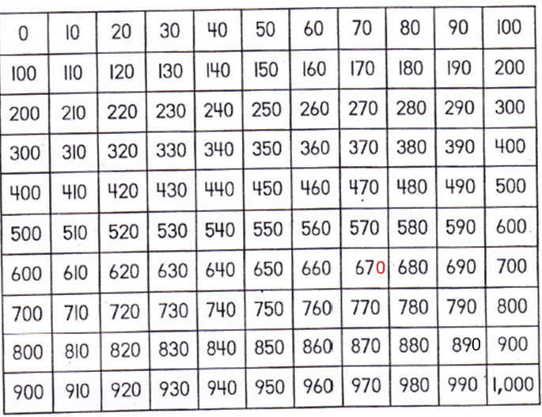

These are words that remind us to round.

